**Replica nginx (compose)**

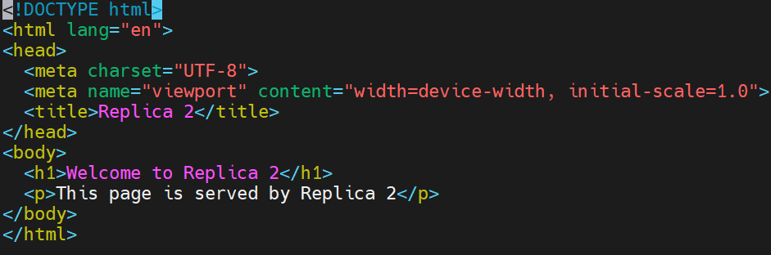

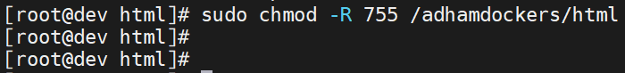



**Another answer**

